## **Today’s Agenda**

* UF Engaged Mission
* Quarterly Check-In Process
* Probationary Check-In Process
* Special Performance Improvement Plan Process
* System Features for Administrators

## Your Role as HR Liaisons

As the HR Liaison with UFHR for your College/Unit, you play an essential role to the success of employees at UF. Your partnership as HR leaders is key to moving HR initiatives forward and disseminating information to our vast employee population. Your collaboration, communication, and feedback are valued, and we thank you for your participation as we continue to elevate the role of HR at UF together.

## Mission of UF Engaged

* To facilitate more **frequent conversations** in a less concentrated time.
* To encourage leaders to be more **intentional** and **deliberate** about the kind of feedback they are giving.
* To provide an organized framework based on employees’ position anniversary dates.
* To reduce paperwork, freeing up more time to **focus on work.**

## 

## Quarterly Check-In Life Cycle

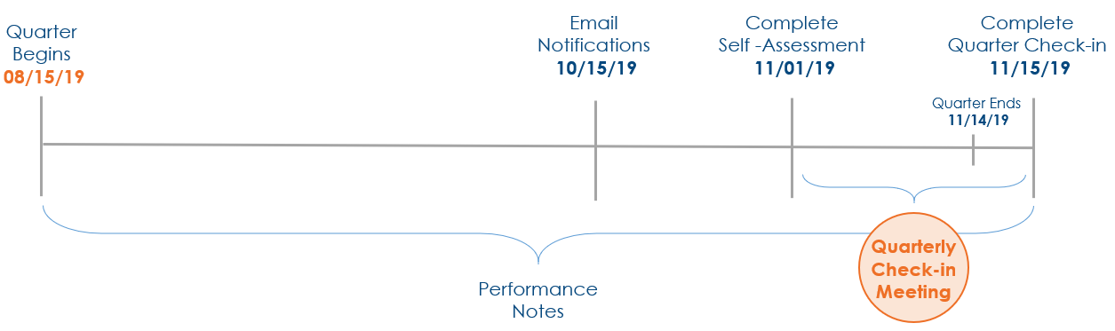

Landon’s Key Dates

* Hire Date – 09/01/08
* New Position Entry Date – 02/15/13

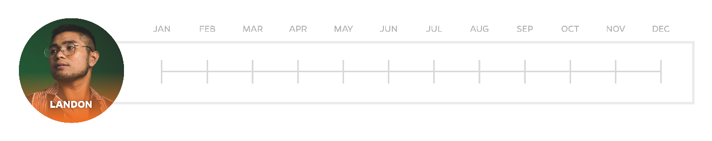

Landon’s Quarterly Check-In Cycle remains the same until he changes position numbers.

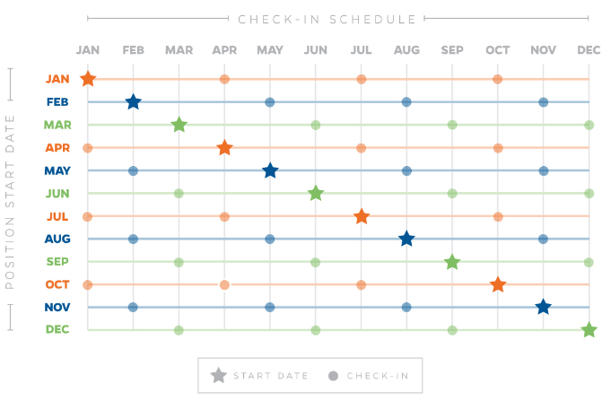

The Check-In Schedule allows you to identify the month you were hired into your current position, signified with the star, and easily identify your quarterly check-in months, signified with the dot.

## Probationary Check-In

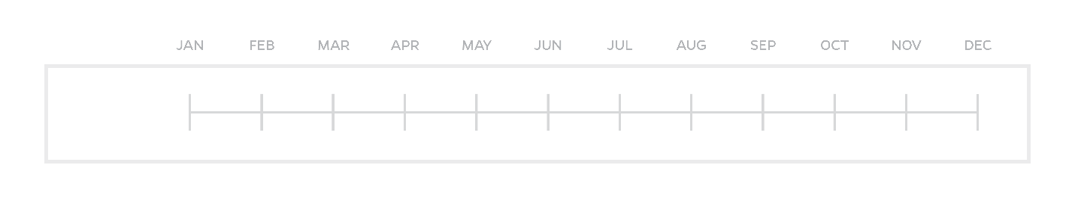

6-Month

Mid-Point

Sarah’s Key Dates

* Hired 03/12/2019
* Mid-Point Check-In 06/12/2019
* 6-Month Probation Check-In 09/12/2019

Standard Operation Procedure for Probation Extensions

* Supervisors will contact and discuss the need for a Probation Extension with their HR Liaison
* HR Liaisons will contact their Employee Relations Satellite Office for review/approval
* HR Liaisons will work with department leaders to initiate the process
* Leaders will select the ‘extension’ option through myUFL during the Six-Month Probation Check-in.
  + Extensions may be requested but cannot be initiated until (30) days prior to the probationary due date.
  + Extensions will be approved in 3-month intervals only
  + Leaders will be able to select the ‘extension’ option thirty (30) days prior to the probationary due date
  + ER will approve or deny the request via myUFL, which will be routed to, and viewed by, the leader.
  + Employee Relations will be in contact with departmental HR Liaisons throughout this step.
* The Leader will have a conversation with the employee explaining the extension and the areas of concerns necessary for satisfaction of the probationary period.
* A Probationary Dismissal can be requested at any time during the probationary period.

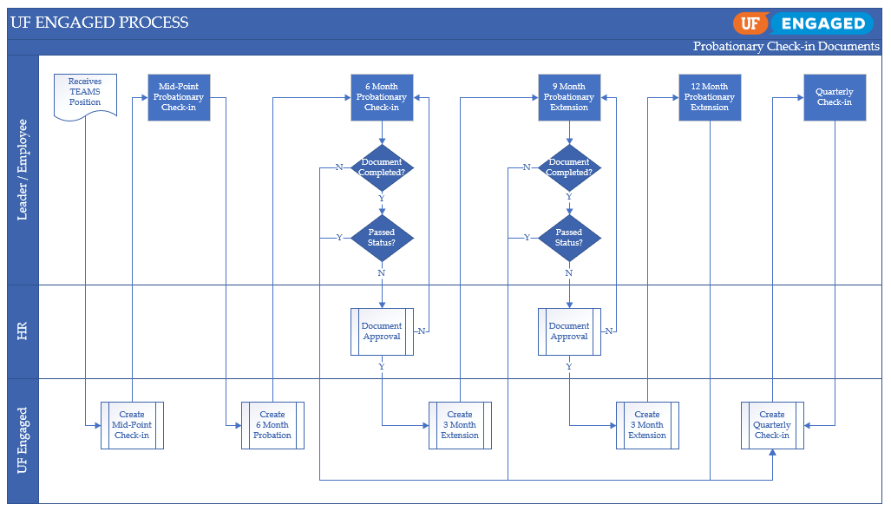

## Special Performance Improvement Plan (S.PIP)

* Supervisors will contact and discuss the need for a S.PIP with their HR Liaison
* HR Liaisons will contact their Employee Relations Satellite Office for guidance/next steps
* HR Liaisons will work with department leaders to initiate the process
  1. Justification for the action will be gathered
* HR Liaisons will work with ER
  1. Review justification and confirm that a S. PIP is warranted
  2. Create the S.PIP on template outside of the myUFL system
  3. Once the content of the S.PIP is agreed to be appropriate, a date is determined as to when UFHR Employee Relations will create the S.PIP in the myUFL system
* ER will create the S. PIP and send to the appropriate Leader through myUFL.
  1. The document will expire 5 calendars days after the creation date
  2. Leaders will fill in the content for the four (4) objectives listed
  3. The Leader will have an extensive conversation with the employee explaining the Special Performance Improvement Plan and the areas of concerns notated on the document as well as expectations moving forward.

## **Special Performance Improvement Plan Process Map**

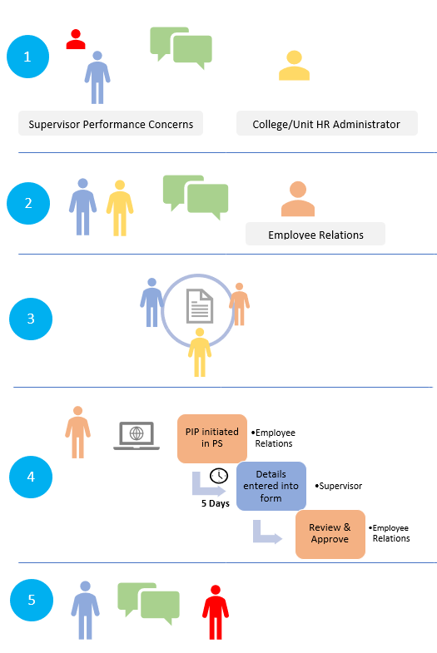

## **System Features for HRL**

**Security Role**

UF_HR_UFENGAGED_LIAISON

**Navigation**

Human Resources 🡪 Workforce Development 🡪 Performance Management 🡪 Performance Documents 🡪 View Documents

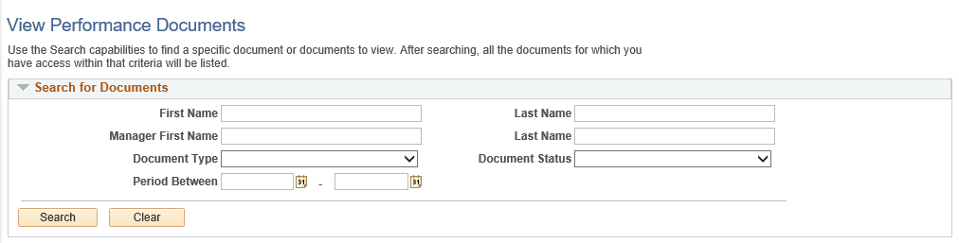

## Document Status’

* Evaluation in Progress
* Completed
* Cancel
* Approval

## Document Types

* Mid-Point Check-in
* 6-Month Probationary
* Extended Probation Check-in
* Quarterly Check-in
* Special Perf Improvement Plan

**NOTE***:* When **supervisors** navigate to Human Resources 🡪 Manager Self Service 🡪 UF Engaged 🡪 Performance Documents they will see the option of Current Documents, Historical Documents and View-Only Documents. HR Liaisons will see all documents under View Documents regardless of whether they are current or historical.

* **Current Documents:** In-Progress Check-ins
* **Historical Documents:** Completed or Cancelled Check-ins
* **View-Only Documents:** Check-ins for Direct and Indirect Reports



## Transferring Documents

Human Resources 🡪 Workforce Development 🡪 Performance Management 🡪 Performance Documents 🡪 Administrative Tasks 🡪 Transfer Document

Any document not listed with a status of Canceled can be transferred to a different manager.

1. Select Document to Transfer
2. Click Select a Manager
3. Search for correct Manager and select
4. Confirm

## Shredder

## Cancelling Documents

Human Resources 🡪 Workforce Development 🡪 Performance Management 🡪 Performance Documents 🡪 Administrative Tasks 🡪 Cancel Document

An open document can be canceled so that entry by the employee and manager will not occur. This document will still reside in the system unless the Delete process is run.

1. Select Document to Cancel
2. Confirm Cancellation
3. Save

## Document

## Reporting

Two available reports:

* UF Engaged - Reports To
* UF Engaged – Docs View

## UF Engaged – Reports To

This report will provide you with reporting relationships based on your search criteria selected.

**Navigation**

Main Menu 🡪 Enterprise Analytics 🡪 Access Enterprise Analytics

1. Enter UF Engaged into the Search field
2. Select UF Engaged – Reports To report
3. Enter any of the Optional Prompts (Department, Supervisor ID, Employee ID)
4. Select Finish

Report Features

* Use the Filter options to quickly sort and view data
* Use the Run option to download the data in the format of choice

## UF Engaged – Docs View

This report will provide you with document statuses based on your search criteria selected.

**Navigation**

Main Menu 🡪 Enterprise Analytics 🡪 Access Enterprise Analytics

1. Enter UF Engaged into the Search field
2. Select UF Engaged – Docs View report
3. Enter any of the Optional Prompts (Department, Review Type, Supervisor ID, Employee ID)
4. Select Finish

Report Features

* Use the Filter options to quickly sort and view data
* Use the Run option to download the data in the format of choice



## Questions?

Email Address: [UFEngaged@hr.ufl.edu](mailto:UFEngaged@hr.ufl.edu)

## Guides/Simulations/Trainings/FAQs

Website: <https://hr.ufl.edu/manager-resources/employee-relations/uf-engaged/>

## Instruction Guides and Simulations Available Online Now

For Leaders

* Performance Notes (Instruction Guide/Simulation)
* Quarterly Check-in (Instruction Guide/Simulation)
* Six Month Probation Check-in (Instruction Guide/Simulation)
* Special Performance Improvement Plan (Instruction Guide/Simulation)

For Staff Employees

* Performance Notes (Instruction Guide/Simulation)
* Employee Self-Assessment (Instruction Guide/Simulation)