# Administrator Tasks for Performance Documents

The following instructions will walk you through how to View, Transfer, Cancel, and Delete performance documents in UF Engaged.

## 

## Navigation

Login into myUFL and navigate to:

**Nav Bar > Main Menu > Human Resources > Workforce Development > Performance Management > Administrative Tasks**

Please note that each of the following processes will be a separate item in the **Administrative Tasks** folder in myUFL.

## View Documents

The **View Documents** function enables you to view all documents in your college/unit as well as sort by Document Type and Status. Here is a list of Document Types and Document Statuses you will be able to access:

|  |  |
| --- | --- |
| **Document Types:**   * Mid-Point Probation Check-in * Six Month Probation Check-in * Extend 9MO Probation Check-in * Extend 12MO Probation Check-in * Quarterly Check-in * Special Perf Improvement Plan | **Document Status:**   * Evaluation in Progress * Completed * Canceled * Approval |

1. You can use the **filter** page to fill in any or all data elements, depending on what you are searching for. Any and all filters can be used individually or together. The following three screen shots are just a few of the several filter options available to a user.

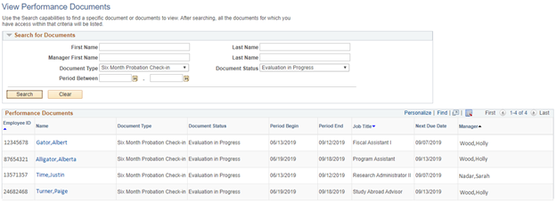

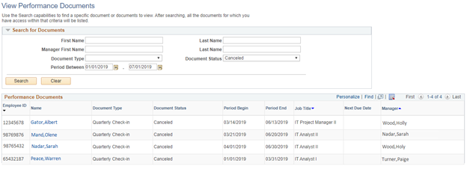

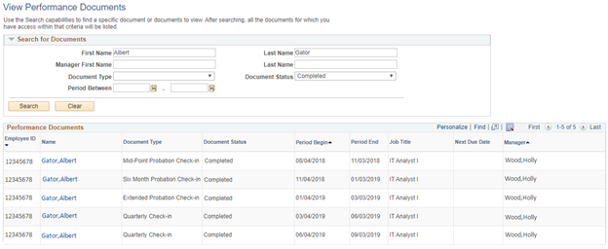

## Transfer Documents

**Transfer Documents** is a function that allows an HR Administrator to transfer performance documents from one supervisor to another.

1. Select **Documents** to Transfer and the click the **Continue** button.

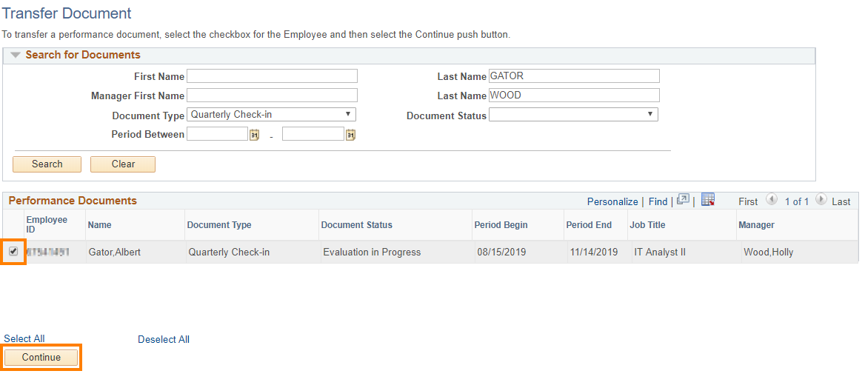

1. Click **Select a Manager**.

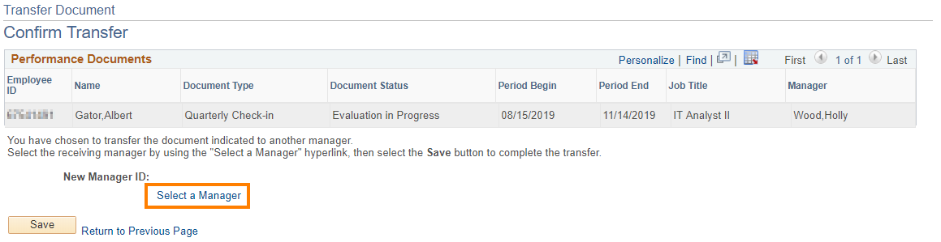

1. Select a **Manager** and click **OK.**

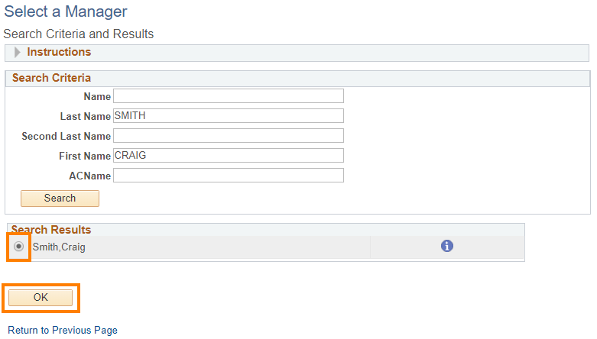

1. Click **Save** to confirm Transfer.

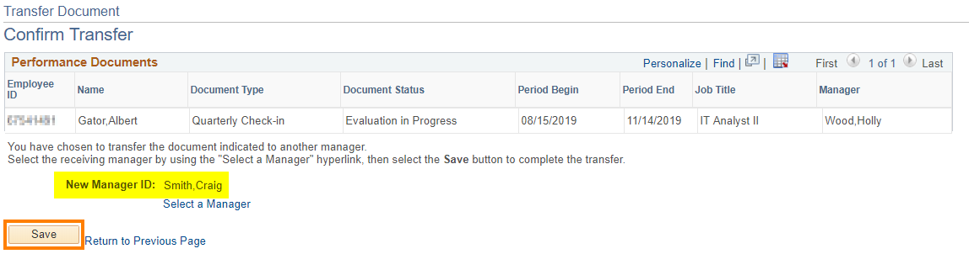

## Cancel Documents

**Cancel Documents** is a function that allows an HR Administrator to cancel performance documents created or submitted in error. A document will need to be cancelled if an employee has a change in position due to promotion, demotion, termination, etc. and a Quarterly Check-in will not be completed.

1. Select **Documents** to Cancel and the click the **Continue** button.

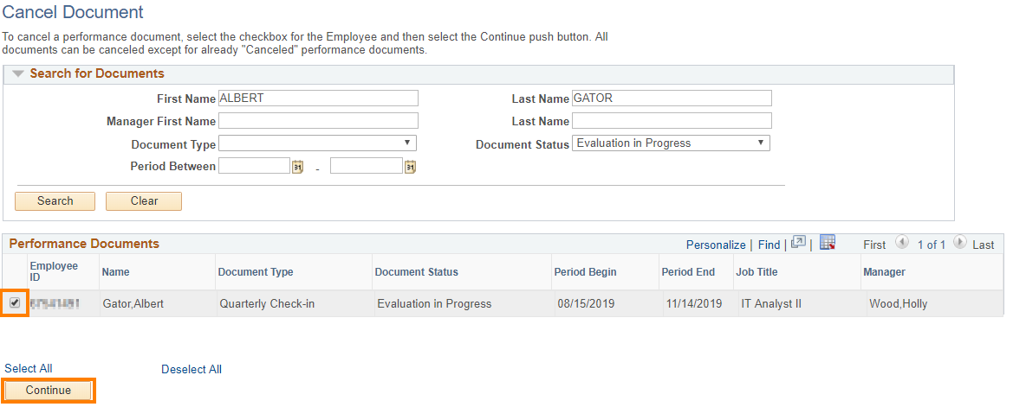

1. Click the **Save** button to confirm Cancellation.

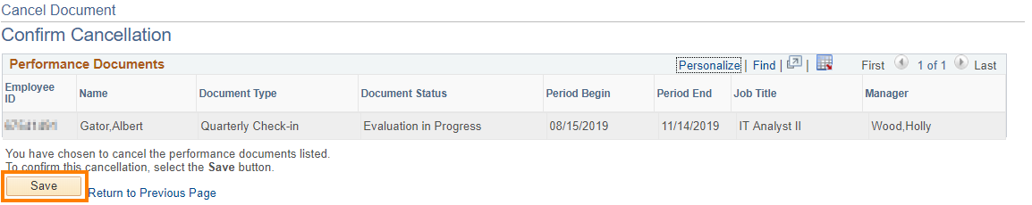

1. Click the **OK** button.

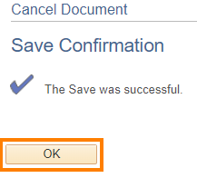

## Delete Documents

**Delete Documents** is a function that allows an HR Administrator to delete performance documents. Prior to deleting a document, you need to consult with UFHR Employee Relations.

1. Select **Documents** to Delete and the click the **Continue** button.

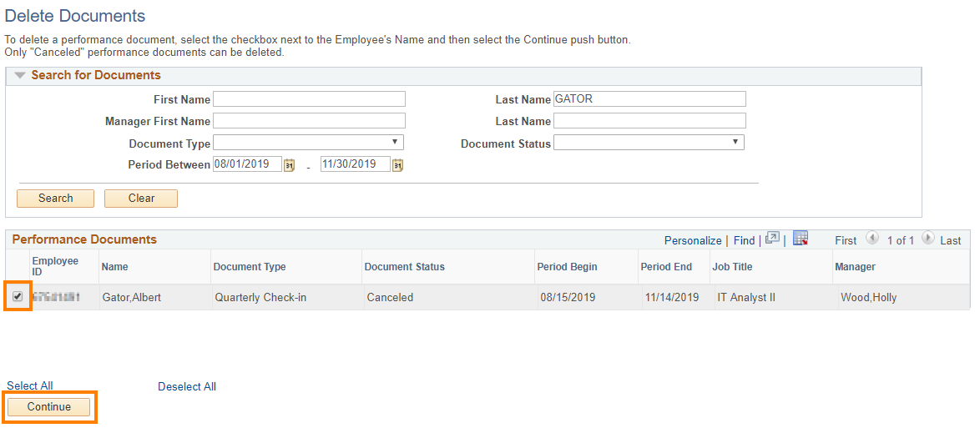

1. Click the **Save** button.

